Name:_____________________________________Period/Day:____________Date:_____________________
Badminton Study Guide

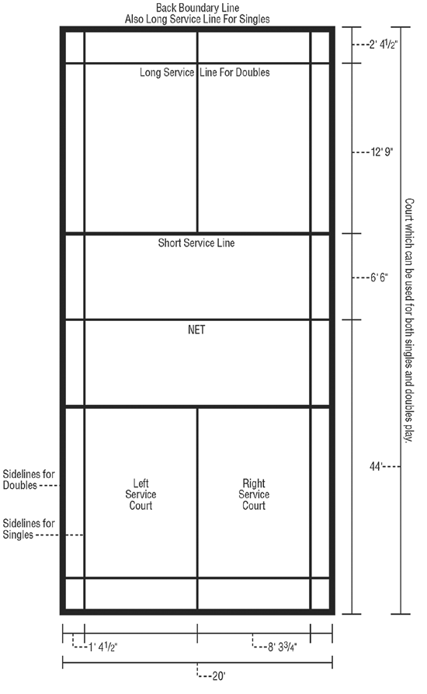
PARTS OF A BADMINTON COURT

1. A match shall consist of the best of _____ games.

2. A game shall be won by the side which first scores _______ points.

- If the score becomes 20-all, who shall win the game? ________________________________________.

- If the score becomes 29-all, who shall win the game? ________________________________________.

3. List 3 serving faults.
1.
2.
3.

4. List 3 faults that may occur during regular play.
1.
2.
3.
Directions: Match the definition with its correct term. Write the letter on the line.

- balk
- clear
- drive
- drop shot
- fault
- foot fault
- inning
- let
- match
- rally
- serve
- singles
- smash
- stroke
- toss

- A shot that initiates play.

- How it is determined who will serve first and from which court.

- Used to indicate a player hindering an opponent.

- A forward movement of the player’s racket.

- A stroke that sends the shuttle high and deep to the back of the court.

- A powerful downward stroke using wrist snap to end the point.

- A hard, horizontal stroke that just clears the net.

- A match where there is one player on each of the opposing sides.

- A stroke in which the shuttle falls just over the net to the floor.

- A sequence of one or more strokes starting with the service, until the shuttle ceases to be in play.

- Denotes an infraction of the rules resulting in a point.

- The basic contest in Badminton between opposing sides each of one or two players. (Best of 3 games.)

- Standing on or over the service court boundary line by either receiver/server.

- Permitting the serve to be taken over or to replay a point.

- A side’s turn at serving.

- Each time a side gains the right to serve, the person who served at the beginning of the game always serves first.

- ___ The first service of the game is from the left service court.

- Only the serving team can score points in badminton.

- If the server scores a point, she continues serving.

- You have two tries to get a good serve in badminton.

- In doubles during a rally, partners must alternate hitting the birdie.

Directions: Write a (+) for true statements and an (o) for false statements.

- If a player hits the birdie, her partner may hit it a second time to help it over.

- A birdie which lands on the line and bounces out of bounds is no good.

- A player may touch the net with her racket as long as she does not interfere with her opponent’s return.

- During a rally, the birdie must go beyond the short service line.

- If a serve is hit by the wrong receiver, the server gets a point.

- A game in badminton is 15.

- It shall be a fault, if the shuttle passes through or under the net during play.

- When a let occurs, play since the last service shall not count and the player who served last shall lose
her serve.

- Rachael’s serve is a fault; it is her partner’s turn to serve. They should exchange positions on the court.

- On the serve, Sada strikes the birdie with the head of the racket above her waist. Sada loses the serve.

- On the serve, Laura serves to the wrong court and her opponent catches the birdie. Laura scores a point.

- During the rally, Jessica runs into the net as she hits a smash which her opponent fails to return. Her partner had served. Jessica’s team wins the point.

Badminton Scoring System
For Singles matches, the rules are:
-A match consists of best of 3 games.
-The side that first scored 21 points shall win.
-The side winning a rally shall add 1 point to its score.
-If a score becomes 20-20, the side which scores 2 consecutive points shall win that game.
-If the score becomes 29-29, the side that scores the 30th point shall win that game.
-The side winning a game serves first in the next game.
-When one side reaches 11 points, both players get a 60 second break.
-Both sides get a 2-minute break between first and second games, and another 2-minute break between second and third game.
-Other rules shall remain the same.
For Doubles matches, the rules are:
-One service only
-Back service line remains and the current rule applies.
Badminton 21-Point Scoring System
The chart below explains the 21 rally point scoring system for doubles matches.
In a Doubles match between A&B against C&D. A&B win the toss and decide to serve. A will serve to C. A shall be the initial server while C shall be the initial receiver.
Course of Action/ Explanation | Score | . | . | Service from Service Court | Server & Receiver | Winner of the Rally
. | Love All | C | D | Right service court. Being the score of the serving side is even. | A serves to C. A and C are the initial server and receiver. | A & B
. | Love All | B | A |  | A serves to C. A and C are the initial server and receiver. | A & B
A & B win a point. A & B will change service courts. A serves again from Left service court. C & D will stay in the same service courts. | 1-0 | C | D | Left service court. Being the score of the serving side is odd. | A serves to D | C & D
 | 1-0 | A | B |  | A serves to D | C & D
C & D win a point and also right to serve. Nobody will change their respective service courts. | 1-1 | C | D | Left service court. Being the score of the serving side is odd. | D serves to A | A & B
 | 1-1 | A | B |  | D serves to A | A & B
A & B win a point and also right to serve. Nobody will change their respective service courts. | 2-1 | C | D | Right service court. Being the score of the serving side is even. | B serves to C | C & D
 | 2-1 | A | B |  | B serves to C | C & D
C & D win a point and also right to serve. Nobody will change their respective service courts. | 2-2 | C | D | Right service court. Being the score of the serving side is even. | C serves to B | C & D
 | 2-2 | A | B |  | C serves to B | C & D
C & D win a point. C & D will change service courts. C serves from Left service court. A & B will stay in the same service courts. | 3-2 | D | C | Left service court. Being the score of the serving side is odd. | C serves to A | A & B
 | 3-2 | A | B |  | C serves to A | A & B
A & B win a point and also right to serve. Nobody will change their respective service courts. | 3-3 | D | C | Left service court. Being the score of the serving side is odd. | A serves to C | A & B
 | 3-3 | A | B |  | A serves to C | A & B
A & B win a point. A & B will change service courts. A serves again from Right service court. C & D will stay in the same service courts. | 4-3 | D | C | Right service court. Being the score of the serving side is even. | A serves to D | C & D
 | 4-3 | B | A |  | A serves to D | C & D

